

Лабораторная работа № 18
Тема: Использование кистей в WPF-приложениях.
По дисциплине: Разработка программных модулей=

Выполнил: студент группы ИС-24
Пашина Валентина

г. Улан-Удэ
2026 г.

Пример 1
Листинг кода:
<Window x:Class="LR18.Example1_ScrollViewer"
xmlns="http://schemas.microsoft.com/winfx/2006/xaml/presentation"
xmlns:x="http://schemas.microsoft.com/winfx/2006/xaml"
Title="Пример 1 - ScrollViewer" Height="400" Width="500"
WindowStartupLocation="CenterOwner">
<Grid Margin="10">
<Grid.RowDefinitions>
<RowDefinition Height="Auto"/>
<RowDefinition Height="*"/>
<RowDefinition Height="Auto"/>
</Grid.RowDefinitions>
<TextBlock Text="Пример 1 - ScrollViewer" FontSize="18" FontWeight="Bold" Margin="0,0,0,10"/>
<TextBlock Grid.Row="1" Text="ScrollViewer позволяет прокручивать содержимое, которое не помещается в области"
TextWrapping="Wrap" Margin="0,0,0,10"/>
<Border Grid.Row="2" BorderBrush="#3498DB" BorderThickness="2" CornerRadius="10">
<ScrollViewer HorizontalScrollBarVisibility="Auto" VerticalScrollBarVisibility="Auto" Height="250">
<StackPanel Margin="10">
<Border Background="#E74C3C" CornerRadius="5" Margin="0,2"><TextBlock Text="Элемент 1" Foreground="White" Padding="10" FontWeight="Bold"/></Border>
<Border Background="#3498DB" CornerRadius="5" Margin="0,2"><TextBlock Text="Элемент 2" Foreground="White" Padding="10" FontWeight="Bold"/></Border>
<Border Background="#2ECC71" CornerRadius="5" Margin="0,2"><TextBlock Text="Элемент 3" Foreground="White" Padding="10" FontWeight="Bold"/></Border>
<Border Background="#F39C12" CornerRadius="5" Margin="0,2"><TextBlock Text="Элемент 4" Foreground="White" Padding="10" FontWeight="Bold"/></Border>
<Border Background="#9B59B6" CornerRadius="5" Margin="0,2"><TextBlock Text="Элемент 5" Foreground="White" Padding="10" FontWeight="Bold"/></Border>
<Border Background="#1ABC9C" CornerRadius="5" Margin="0,2"><TextBlock Text="Элемент 6" Foreground="White" Padding="10" FontWeight="Bold"/></Border>
<Border Background="#E67E22" CornerRadius="5" Margin="0,2"><TextBlock Text="Элемент 7" Foreground="White" Padding="10" FontWeight="Bold"/></Border>
<Border Background="#34495E" CornerRadius="5" Margin="0,2"><TextBlock Text="Элемент 8" Foreground="White" Padding="10" FontWeight="Bold"/></Border>
<TextBlock Text="Горизонтальная прокрутка:" FontWeight="Bold" Margin="0,15,0,5"/>
<Grid>
<Grid.ColumnDefinitions>
<ColumnDefinition Width="120"/><ColumnDefinition Width="120"/>
<ColumnDefinition Width="120"/><ColumnDefinition Width="120"/>
<ColumnDefinition Width="120"/>
</Grid.ColumnDefinitions>
<Border Grid.Column="0" Background="#34495E" Padding="5" Margin="1"><TextBlock Text="Столбец 1" Foreground="White"/></Border>
<Border Grid.Column="1" Background="#34495E" Padding="5" Margin="1"><TextBlock Text="Столбец 2" Foreground="White"/></Border>
<Border Grid.Column="2" Background="#34495E" Padding="5" Margin="1"><TextBlock Text="Столбец 3" Foreground="White"/></Border>
<Border Grid.Column="3" Background="#34495E" Padding="5" Margin="1"><TextBlock Text="Столбец 4" Foreground="White"/></Border>
<Border Grid.Column="4" Background="#34495E" Padding="5" Margin="1"><TextBlock Text="Столбец 5" Foreground="White"/></Border>
</Grid>
</StackPanel>
</ScrollViewer>
</Border>
<Button Grid.Row="3" Content="Закрыть" Width="100" Height="30" Margin="0,15,0,0" Click="Close_Click"/>
</Grid>
</Window>
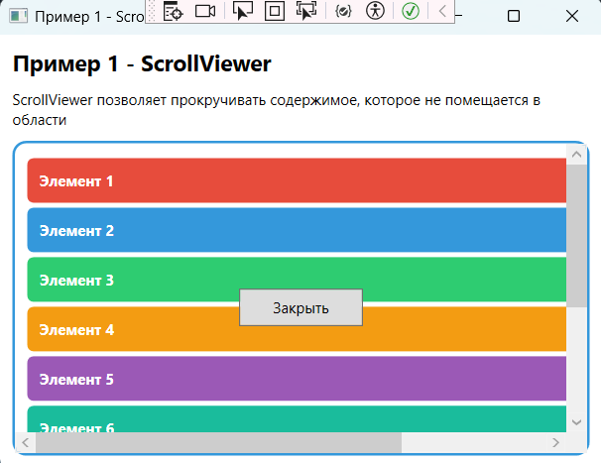
Рис. 1 «Результат»

Пример 2
Листинг кода:
<Window x:Class="LR18.Example2_BorderExpander"
xmlns="http://schemas.microsoft.com/winfx/2006/xaml/presentation"
xmlns:x="http://schemas.microsoft.com/winfx/2006/xaml"
Title="Пример 2 - Border и Expander" Height="520" Width="550"
WindowStartupLocation="CenterOwner">
<Grid Margin="10">
<Grid.RowDefinitions>
<RowDefinition Height="Auto"/>
<RowDefinition Height="Auto"/>
<RowDefinition Height="Auto"/>
<RowDefinition Height="Auto"/>
<RowDefinition Height="Auto"/>
<RowDefinition Height="Auto"/>
<RowDefinition Height="*"/>
<RowDefinition Height="Auto"/>
</Grid.RowDefinitions>
<TextBlock Text="Пример 2 - Border и Expander" FontSize="18" FontWeight="Bold" Margin="0,0,0,10"/>
<TextBlock Grid.Row="1" Text="Border с закругленными углами:" FontWeight="Bold" Margin="0,10,0,5"/>
<Border Grid.Row="2" BorderBrush="#3498DB" BorderThickness="3" CornerRadius="15"
Background="#ECF0F1" Padding="15" Margin="0,0,0,10">
<TextBlock Text="Border с радиусом закругления 15" FontSize="14" Foreground="#2C3E50"/>
</Border>
<TextBlock Grid.Row="3" Text="Border с разными радиусами углов:" FontWeight="Bold" Margin="0,10,0,5"/>
<Border Grid.Row="4" BorderBrush="#E74C3C" BorderThickness="2" CornerRadius="20,5,20,5"
Background="#FADBD8" Padding="15" Margin="0,0,0,10">
<TextBlock Text="CornerRadius: 20,5,20,5" FontSize="14" Foreground="#C0392B"/>
</Border>
<TextBlock Grid.Row="5" Text="Expander:" FontWeight="Bold" Margin="0,10,0,5"/>
<StackPanel Grid.Row="6">
<Expander Header="Раздел 1 - Информация" IsExpanded="True" Margin="0,5">
<Border Background="#ECF0F1" CornerRadius="5" Padding="10">
<TextBlock Text="Это содержимое можно скрыть или показать, нажав на заголовок" TextWrapping="Wrap"/>
</Border>
</Expander>
<Expander Header="Раздел 2 - Кисти WPF" Margin="0,5">
<StackPanel>
<Border Background="#2ECC71" CornerRadius="5" Margin="0,2">
<TextBlock Text="SolidColorBrush - сплошная заливка" Foreground="White" Padding="10"/>
</Border>
<Border Background="#3498DB" CornerRadius="5" Margin="0,2">
<TextBlock Text="LinearGradientBrush - линейный градиент" Foreground="White" Padding="10"/>
</Border>
<Border Background="#9B59B6" CornerRadius="5" Margin="0,2">
<TextBlock Text="RadialGradientBrush - радиальный градиент" Foreground="White" Padding="10"/>
</Border>
</StackPanel>
</Expander>
<Expander Header="Раздел 3 - Раскрытие вверх" ExpandDirection="Up" Margin="0,5">
<Border Background="#F39C12" CornerRadius="5" Padding="10">
<TextBlock Text="Этот Expander раскрывается вверх!" Foreground="White"/>
</Border>
</Expander>
</StackPanel>
<Button Grid.Row="7" Content="Закрыть" Width="100" Height="30" Margin="0,15,0,0" Click="Close_Click"/>
</Grid>
</Window>
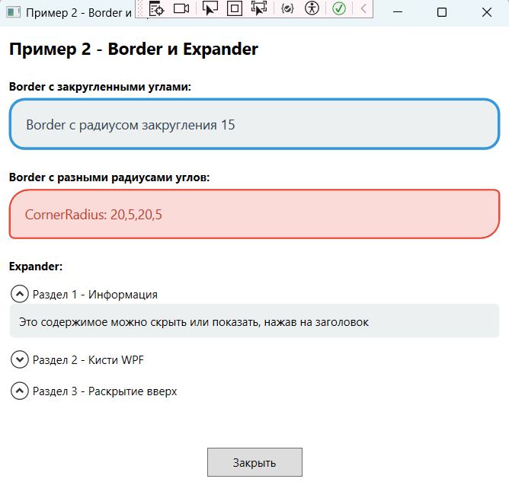
Рис. 2 «Результат»

Пример 3
Листинг кода:
<Window x:Class="LR18.Example3_TabControl"
xmlns="http://schemas.microsoft.com/winfx/2006/xaml/presentation"
xmlns:x="http://schemas.microsoft.com/winfx/2006/xaml"
Title="Пример 3 - TabControl" Height="400" Width="500"
WindowStartupLocation="CenterOwner">
<Grid Margin="10">
<Grid.RowDefinitions>
<RowDefinition Height="Auto"/>
<RowDefinition Height="*"/>
<RowDefinition Height="Auto"/>
</Grid.RowDefinitions>
<TextBlock Text="Пример 3 - TabControl" FontSize="18" FontWeight="Bold" Margin="0,0,0,10"/>
<TabControl Grid.Row="1">
<TabItem Header="Вкладка 1">
<StackPanel Margin="10">
<TextBlock Text="Это содержимое первой вкладки" FontSize="14" Margin="0,0,0,10"/>
<Button Background="#E74C3C" Foreground="White" FontSize="16" Height="50" Content="Красная кнопка"/>
</StackPanel>
</TabItem>
<TabItem Header="Вкладка 2">
<StackPanel Margin="10">
<TextBlock Text="Это содержимое второй вкладки" FontSize="14" Margin="0,0,0,10"/>
<Button Background="#2ECC71" Foreground="White" FontSize="16" Height="50" Content="Зеленая кнопка"/>
</StackPanel>
</TabItem>
<TabItem Header="Вкладка 3">
<StackPanel Margin="10">
<TextBlock Text="Это содержимое третьей вкладки" FontSize="14" Margin="0,0,0,10"/>
<Button Background="#3498DB" Foreground="White" FontSize="16" Height="50" Content="Синяя кнопка"/>
</StackPanel>
</TabItem>
<TabItem Header="Вкладка 4">
<StackPanel Margin="10">
<TextBlock Text="Кнопки с градиентом" FontSize="14" Margin="0,0,0,10"/>
<Button Margin="0,5" Height="50">
<Button.Background>
<LinearGradientBrush StartPoint="0,0" EndPoint="1,0">
<GradientStop Offset="0" Color="#FF6B6B"/>
<GradientStop Offset="1" Color="#EE5A24"/>
</LinearGradientBrush>
</Button.Background>
<TextBlock Text="Градиент 1" Foreground="White"/>
</Button>
<Button Margin="0,5" Height="50">
<Button.Background>
<LinearGradientBrush StartPoint="0,0" EndPoint="1,1">
<GradientStop Offset="0" Color="#4ECDC4"/>
<GradientStop Offset="1" Color="#2C3E50"/>
</LinearGradientBrush>
</Button.Background>
<TextBlock Text="Градиент 2" Foreground="White"/>
</Button>
</StackPanel>
</TabItem>
</TabControl>
<Button Grid.Row="2" Content="Закрыть" Width="100" Height="30" Margin="0,15,0,0" Click="Close_Click"/>
</Grid>
</Window>
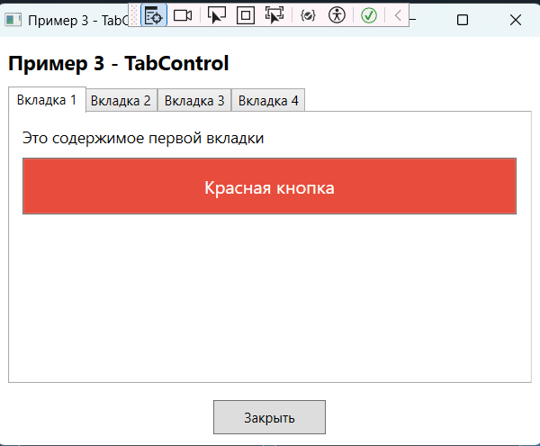
Рис. 3 «Результат»

Пример 4
Листинг кода:
<Window x:Class="LR18.Example4_Brushes"
xmlns="http://schemas.microsoft.com/winfx/2006/xaml/presentation"
xmlns:x="http://schemas.microsoft.com/winfx/2006/xaml"
Title="Пример 4 - Типы кистей" Height="683" Width="550"
WindowStartupLocation="CenterOwner">
<Grid Margin="15">
<Grid.RowDefinitions>
<RowDefinition Height="Auto"/>
<RowDefinition Height="*"/>
<RowDefinition Height="Auto"/>
</Grid.RowDefinitions>
<TextBlock Text="Пример 4 - Типы кистей" FontSize="18" FontWeight="Bold" Margin="0,0,0,10"/>
<ScrollViewer Grid.Row="1" VerticalScrollBarVisibility="Auto">
<StackPanel>
<TextBlock Text="1. SolidColorBrush - сплошная заливка" FontWeight="Bold" FontSize="14" Margin="0,10,0,5"/>
<Rectangle Height="50" Fill="Red" RadiusX="5" RadiusY="5" Margin="0,0,0,10"/>
<TextBlock Text="2. LinearGradientBrush - линейный градиент" FontWeight="Bold" FontSize="14" Margin="0,10,0,5"/>
<Rectangle Height="60" RadiusX="5" RadiusY="5" Margin="0,0,0,10">
<Rectangle.Fill>
<LinearGradientBrush StartPoint="0,0" EndPoint="1,1">
<GradientStop Offset="0" Color="Yellow"/>
<GradientStop Offset="0.5" Color="Orange"/>
<GradientStop Offset="1" Color="Red"/>
</LinearGradientBrush>
</Rectangle.Fill>
</Rectangle>
<TextBlock Text="LinearGradientBrush (вертикальный)" FontSize="12" Margin="0,0,0,5"/>
<Rectangle Height="60" RadiusX="5" RadiusY="5" Margin="0,0,0,10">
<Rectangle.Fill>
<LinearGradientBrush StartPoint="0,0" EndPoint="0,1">
<GradientStop Offset="0" Color="#3498DB"/>
<GradientStop Offset="0.5" Color="#2ECC71"/>
<GradientStop Offset="1" Color="#E74C3C"/>
</LinearGradientBrush>
</Rectangle.Fill>
</Rectangle>
<TextBlock Text="3. RadialGradientBrush - радиальный градиент" FontWeight="Bold" FontSize="14" Margin="0,10,0,5"/>
<Grid>
<Grid.ColumnDefinitions>
<ColumnDefinition Width="*"/>
<ColumnDefinition Width="*"/>
</Grid.ColumnDefinitions>
<Ellipse Grid.Column="0" Height="120" Width="120" Margin="5">
<Ellipse.Fill>
<RadialGradientBrush GradientOrigin="0.3,0.3">
<GradientStop Offset="0" Color="White"/>
<GradientStop Offset="0.5" Color="#3498DB"/>
<GradientStop Offset="1" Color="#2C3E50"/>
</RadialGradientBrush>
</Ellipse.Fill>
</Ellipse>
<Ellipse Grid.Column="1" Height="120" Width="120" Margin="5">
<Ellipse.Fill>
<RadialGradientBrush GradientOrigin="0.5,0.5">
<GradientStop Offset="0" Color="#FFE66D"/>
<GradientStop Offset="0.4" Color="#F39C12"/>
<GradientStop Offset="1" Color="#D35400"/>
</RadialGradientBrush>
</Ellipse.Fill>
</Ellipse>
</Grid>
<TextBlock Text="Текст с градиентной заливкой" FontSize="24" FontWeight="Bold" TextAlignment="Center" Margin="0,20,0,10">
<TextBlock.Foreground>
<LinearGradientBrush StartPoint="0,0" EndPoint="1,0">
<GradientStop Offset="0" Color="#FF6B6B"/>
<GradientStop Offset="0.3" Color="#4ECDC4"/>
<GradientStop Offset="0.7" Color="#FFE66D"/>
<GradientStop Offset="1" Color="#3498DB"/>
</LinearGradientBrush>
</TextBlock.Foreground>
</TextBlock>
</StackPanel>
</ScrollViewer>
<Button Grid.Row="2" Content="Закрыть" Width="100" Height="30" Margin="0,15,0,0" Click="Close_Click"/>
</Grid>
</Window>
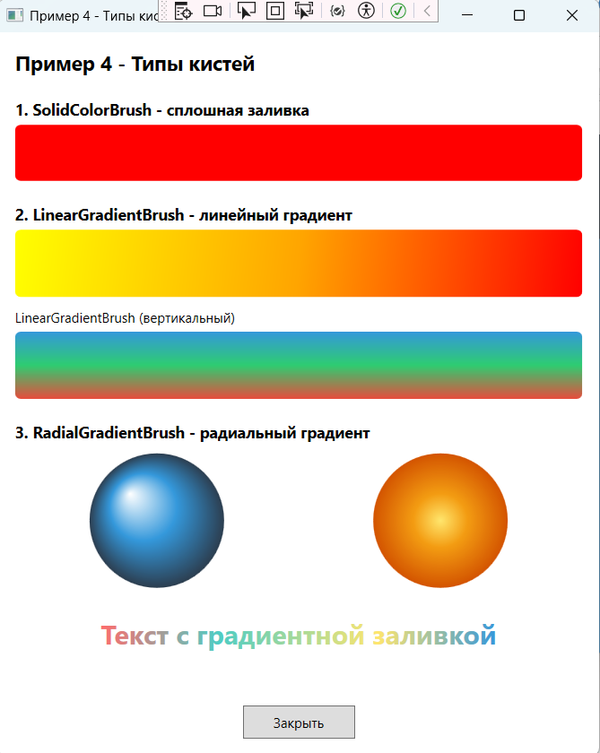
Рис. 4 «Результат»

Задание 1
Листинг кода:
<Window x:Class="LR18.Task1"
xmlns="http://schemas.microsoft.com/winfx/2006/xaml/presentation"
xmlns:x="http://schemas.microsoft.com/winfx/2006/xaml"
Title="Задание 1 - Анимация света" Height="450" Width="500"
WindowStartupLocation="CenterOwner"
Background="#1A1A2E">

<Grid>
<Grid.RowDefinitions>
<RowDefinition Height="Auto"/>
<RowDefinition Height="*"/>
<RowDefinition Height="Auto"/>
</Grid.RowDefinitions>
<TextBlock Text="Задание 1 - Анимация источника света"
FontSize="18" FontWeight="Bold" Foreground="White"
TextAlignment="Center" Margin="0,20"/>
<Grid Grid.Row="1" HorizontalAlignment="Center" VerticalAlignment="Center">
<Ellipse x:Name="Sphere" Width="200" Height="200" Stroke="Gold" StrokeThickness="2">
<Ellipse.Fill>
<RadialGradientBrush x:Name="LightBrush" GradientOrigin="0.5,0.5">
<GradientStop Color="White" Offset="0"/>
<GradientStop Color="Gold" Offset="0.3"/>
<GradientStop Color="Orange" Offset="0.6"/>
<GradientStop Color="DarkRed" Offset="1"/>
</RadialGradientBrush>
</Ellipse.Fill>
<Ellipse.Triggers>
<EventTrigger RoutedEvent="Ellipse.Loaded">
<BeginStoryboard>
<Storyboard RepeatBehavior="Forever" AutoReverse="True">
<PointAnimation
Storyboard.TargetProperty="(Ellipse.Fill).(RadialGradientBrush.GradientOrigin)"
From="0.2,0.2" To="0.8,0.8" Duration="0:0:3"
AutoReverse="True" RepeatBehavior="Forever"/>
</Storyboard>
</BeginStoryboard>
</EventTrigger>
</Ellipse.Triggers>
</Ellipse>
</Grid>
<Button Grid.Row="2" Content="Закрыть" Width="100" Height="35"
Margin="0,20,0,20" HorizontalAlignment="Center"
Click="Close_Click" Background="#555" Foreground="White"
FontSize="14" Cursor="Hand"/>
</Grid>
</Window>
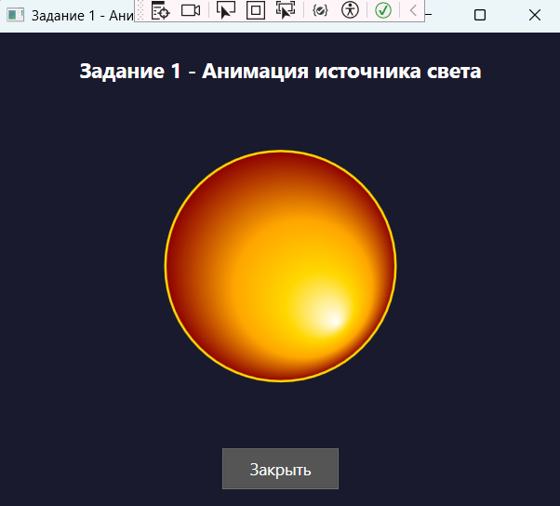
Рис. 5 «Результат»

Задание 2
Листинг кода:
<Window x:Class="LR18.Task2"
xmlns="http://schemas.microsoft.com/winfx/2006/xaml/presentation"
xmlns:x="http://schemas.microsoft.com/winfx/2006/xaml"
Title="Задание 2 - Кастомные кисти" Height="500" Width="550"
WindowStartupLocation="CenterOwner">
<Window.Resources>
<!-- Кастомные кисти -->
<SolidColorBrush x:Key="CustomSolidBrush" Color="Green"/>
<LinearGradientBrush x:Key="CustomLinearBrush" StartPoint="0,0" EndPoint="1,1">
<GradientStop Offset="0" Color="Yellow"/>
<GradientStop Offset="0.5" Color="Orange"/>
<GradientStop Offset="1" Color="Red"/>
</LinearGradientBrush>
<RadialGradientBrush x:Key="CustomRadialBrush" GradientOrigin="0.3,0.3">
<GradientStop Offset="0" Color="White"/>
<GradientStop Offset="0.4" Color="Purple"/>
<GradientStop Offset="1" Color="DarkViolet"/>
</RadialGradientBrush>
<LinearGradientBrush x:Key="ButtonGrad1" StartPoint="0,0" EndPoint="1,0">
<GradientStop Offset="0" Color="#FF6B6B"/>
<GradientStop Offset="1" Color="#EE5A24"/>
</LinearGradientBrush>
<LinearGradientBrush x:Key="ButtonGrad2" StartPoint="0,0" EndPoint="0,1">
<GradientStop Offset="0" Color="#4ECDC4"/>
<GradientStop Offset="1" Color="#2C3E50"/>
</LinearGradientBrush>
</Window.Resources>
<Grid Margin="15">
<Grid.RowDefinitions>
<RowDefinition Height="Auto"/>
<RowDefinition Height="Auto"/>
<RowDefinition Height="Auto"/>
<RowDefinition Height="Auto"/>
<RowDefinition Height="Auto"/>
<RowDefinition Height="Auto"/>
<RowDefinition Height="*"/>
<RowDefinition Height="Auto"/>
</Grid.RowDefinitions>
<TextBlock Text="Задание 2 - Создание кастомных кистей"
FontSize="18" FontWeight="Bold" Margin="0,0,0,15"/>
<TextBlock Grid.Row="1" Text="1. SolidColorBrush" FontWeight="Bold" FontSize="14" Margin="0,10,0,5"/>
<Rectangle Grid.Row="2" Height="40" Fill="{StaticResource CustomSolidBrush}"
RadiusX="5" RadiusY="5" Margin="0,0,0,10"/>
<TextBlock Grid.Row="3" Text="2. LinearGradientBrush" FontWeight="Bold" FontSize="14" Margin="0,10,0,5"/>
<Rectangle Grid.Row="4" Height="40" Fill="{StaticResource CustomLinearBrush}"
RadiusX="5" RadiusY="5" Margin="0,0,0,10"/>

<TextBlock Grid.Row="5" Text="3. RadialGradientBrush" FontWeight="Bold" FontSize="14" Margin="0,10,0,5"/>
<Ellipse Grid.Row="6" Height="100" Width="100" Fill="{StaticResource CustomRadialBrush}"
HorizontalAlignment="Left" Margin="0,0,0,10"/>
<StackPanel Grid.Row="6" Orientation="Horizontal" HorizontalAlignment="Right" VerticalAlignment="Top">
<Button Width="120" Height="40" Margin="5" Cursor="Hand">
<Button.Background>
<StaticResource ResourceKey="ButtonGrad1"/>
</Button.Background>
<TextBlock Text="Кнопка 1" Foreground="White" FontWeight="Bold"/>
</Button>
<Button Width="120" Height="40" Margin="5" Cursor="Hand">
<Button.Background>
<StaticResource ResourceKey="ButtonGrad2"/>
</Button.Background>
<TextBlock Text="Кнопка 2" Foreground="White" FontWeight="Bold"/>
</Button>
</StackPanel>
<Button Grid.Row="7" Content="Закрыть" Width="100" Height="35"
Margin="0,20,0,0" HorizontalAlignment="Center"
Click="Close_Click" Background="#555" Foreground="White"
FontSize="14" Cursor="Hand"/>
</Grid>
</Window>
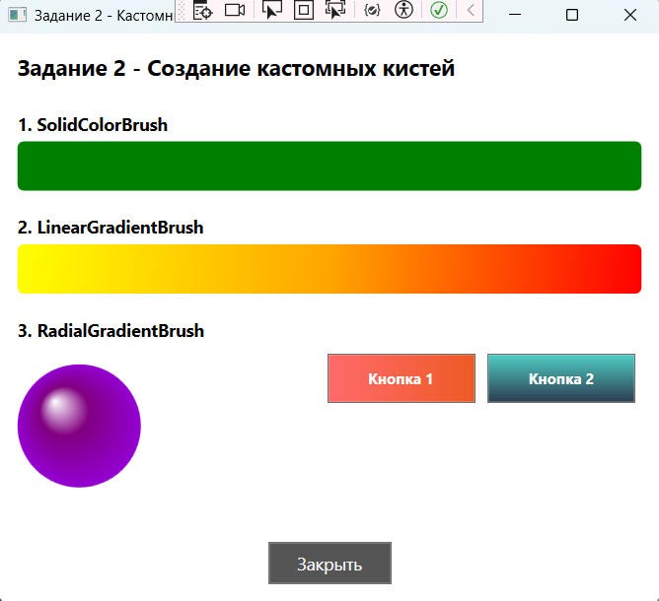
Рис. 6 «Результат»

Задание 3
Листинг кода:
<Window x:Class="LR18.Task3"
xmlns="http://schemas.microsoft.com/winfx/2006/xaml/presentation"
xmlns:x="http://schemas.microsoft.com/winfx/2006/xaml"
Title="Задание 3 - Анимация цвета" Height="400" Width="500"
WindowStartupLocation="CenterOwner">
<Grid Margin="20">
<Grid.RowDefinitions>
<RowDefinition Height="Auto"/>
<RowDefinition Height="Auto"/>
<RowDefinition Height="Auto"/>
<RowDefinition Height="*"/>
<RowDefinition Height="Auto"/>
</Grid.RowDefinitions>
<TextBlock Text="Задание 3 - Анимация с использованием кистей"
FontSize="18" FontWeight="Bold" Margin="0,0,0,20"/>
<TextBlock Grid.Row="1" Text="Нажми на прямоугольник - цвет изменится"
FontSize="12" Foreground="Gray" Margin="0,0,0,10"/>
<Rectangle x:Name="AnimatedRect" Grid.Row="2" Width="200" Height="100"
RadiusX="10" RadiusY="10" HorizontalAlignment="Center">
<Rectangle.Fill>
<SolidColorBrush x:Name="ColorBrush" Color="Red"/>
</Rectangle.Fill>
<Rectangle.Triggers>
<EventTrigger RoutedEvent="Rectangle.MouseLeftButtonDown">
<BeginStoryboard>
<Storyboard>
<ColorAnimation Storyboard.TargetName="ColorBrush"
Storyboard.TargetProperty="Color"
To="Blue" Duration="0:0:1"/>
</Storyboard>
</BeginStoryboard>
</EventTrigger>
</Rectangle.Triggers>
</Rectangle>
<TextBlock Grid.Row="3" Text="Наведи мышь на прямоугольник"
FontSize="12" Foreground="Gray" Margin="0,20,0,10"/>
<Rectangle x:Name="HoverRect" Grid.Row="3" Width="200" Height="60"
RadiusX="10" RadiusY="10" HorizontalAlignment="Center"
VerticalAlignment="Center" Margin="0,30,0,0">
<Rectangle.Fill>
<SolidColorBrush x:Name="HoverBrush" Color="Green"/>
</Rectangle.Fill>
<Rectangle.Triggers>
<EventTrigger RoutedEvent="Rectangle.MouseEnter">
<BeginStoryboard>
<Storyboard>
<ColorAnimation Storyboard.TargetName="HoverBrush"
Storyboard.TargetProperty="Color"
To="Orange" Duration="0:0:0.5"/>
</Storyboard>
</BeginStoryboard>
</EventTrigger>
<EventTrigger RoutedEvent="Rectangle.MouseLeave">
<BeginStoryboard>
<Storyboard>
<ColorAnimation Storyboard.TargetName="HoverBrush"
Storyboard.TargetProperty="Color"
To="Green" Duration="0:0:0.5"/>
</Storyboard>
</BeginStoryboard>
</EventTrigger>
</Rectangle.Triggers>
</Rectangle>
<Button Grid.Row="4" Content="Закрыть" Width="100" Height="35"
Margin="0,30,0,0" HorizontalAlignment="Center"
Click="Close_Click" Background="#555" Foreground="White"
FontSize="14" Cursor="Hand"/>
</Grid>
</Window>
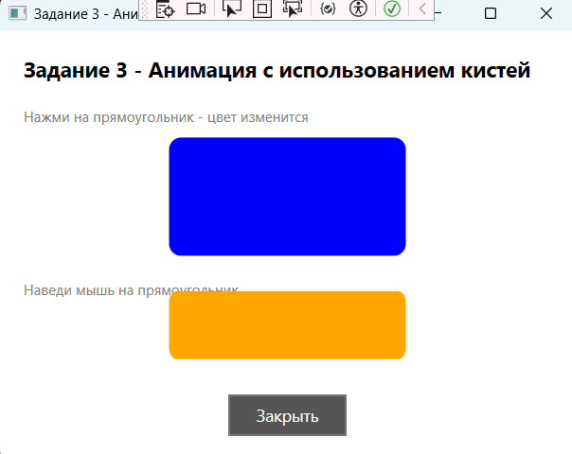
Рис. 7 «Результат»

Главная форма:
<Window x:Class="LR18.MainWindow"
xmlns="http://schemas.microsoft.com/winfx/2006/xaml/presentation"
xmlns:x="http://schemas.microsoft.com/winfx/2006/xaml"
Title="Лабораторная работа №18 - Кисти в WPF"
Height="500" Width="650"
WindowStartupLocation="CenterScreen">
<Window.Resources>
<LinearGradientBrush x:Key="WindowBackground" StartPoint="0,0" EndPoint="1,1">
<GradientStop Offset="0" Color="#2C3E50"/>
<GradientStop Offset="1" Color="#3498DB"/>
</LinearGradientBrush>
<Style x:Key="MenuButtonStyle" TargetType="Button">
<Setter Property="Foreground" Value="White"/>
<Setter Property="FontSize" Value="14"/>
<Setter Property="FontWeight" Value="Bold"/>
<Setter Property="Margin" Value="8"/>
<Setter Property="Padding" Value="12,8"/>
<Setter Property="Height" Value="50"/>
<Setter Property="Width" Value="180"/>
<Setter Property="Cursor" Value="Hand"/>
<Setter Property="Template">
<Setter.Value>
<ControlTemplate TargetType="Button">
<Border Background="{TemplateBinding Background}" CornerRadius="8">
<ContentPresenter HorizontalAlignment="Center" VerticalAlignment="Center"/>
</Border>
<ControlTemplate.Triggers>
<Trigger Property="IsMouseOver" Value="True">
<Setter Property="Background" Value="#2ECC71"/>
</Trigger>
</ControlTemplate.Triggers>
</ControlTemplate>
</Setter.Value>
</Setter>
</Style>
</Window.Resources>
<Grid Background="{StaticResource WindowBackground}">
<Grid.RowDefinitions>
<RowDefinition Height="Auto"/>
<RowDefinition Height="*"/>
</Grid.RowDefinitions>
<Border Grid.Row="0" Background="#1A252F" CornerRadius="0,0,15,15">
<TextBlock Text="Лабораторная работа №18&#xA;Использование кистей в WPF"
FontSize="20" FontWeight="Bold" Foreground="White"
TextAlignment="Center" Padding="20"/>
</Border>
<ScrollViewer Grid.Row="1" VerticalScrollBarVisibility="Auto">
<WrapPanel Margin="15" HorizontalAlignment="Center">
<Border BorderBrush="White" BorderThickness="1" CornerRadius="10" Margin="5" Background="#34495E">
<StackPanel Margin="10">
<TextBlock Text="ПРИМЕРЫ" Foreground="#F1C40F" FontWeight="Bold" FontSize="14" TextAlignment="Center" Margin="0,0,0,10"/>
<Button Style="{StaticResource MenuButtonStyle}" Background="#E67E22"
Click="OpenScrollViewer_Click" Content="1. ScrollViewer"/>
<Button Style="{StaticResource MenuButtonStyle}" Background="#E67E22"
Click="OpenBorderExpander_Click" Content="2. Border и Expander"/>
<Button Style="{StaticResource MenuButtonStyle}" Background="#E67E22"
Click="OpenTabControl_Click" Content="3. TabControl"/>
<Button Style="{StaticResource MenuButtonStyle}" Background="#E67E22"
Click="OpenBrushes_Click" Content="4. Типы кистей"/>
</StackPanel>
</Border>
<Border BorderBrush="White" BorderThickness="1" CornerRadius="10" Margin="5" Background="#34495E">
<StackPanel Margin="10">
<TextBlock Text="ЗАДАНИЯ" Foreground="#F1C40F" FontWeight="Bold" FontSize="14" TextAlignment="Center" Margin="0,0,0,10"/>
<Button Style="{StaticResource MenuButtonStyle}" Background="#9B59B6"
Click="OpenTask1_Click" Content="Задание 1"/>
<Button Style="{StaticResource MenuButtonStyle}" Background="#9B59B6"
Click="OpenTask2_Click" Content="Задание 2"/>
<Button Style="{StaticResource MenuButtonStyle}" Background="#9B59B6"
Click="OpenTask3_Click" Content="Задание 3"/>
</StackPanel>
</Border>
</WrapPanel>
</ScrollViewer>
</Grid>
</Window>
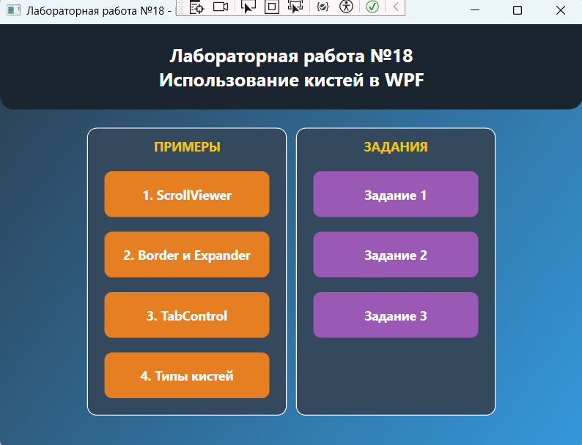
Рис. 8 «Результат»

Контрольные вопросы:
- Что такое Кисти в WPF
- Какие типы кистей есть WPF? Расскажите о них
Ответы:
- Кисти в WPF – это инструменты для заливки фона, текста, границ и фигур. Они определяют визуальное оформление элементов управления.
- Типы кистей:
- SolidColorBrush – заливка одним сплошным цветом
- LinearGradientBrush – плавный переход цветов по прямой линии
- RadialGradientBrush – переход цветов от центра к краям по кругу
- ImageBrush – заливка изображением
- VisualBrush – заливка содержимым другого элемента

